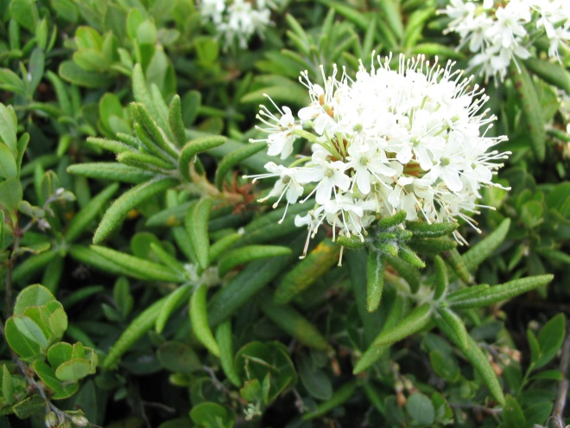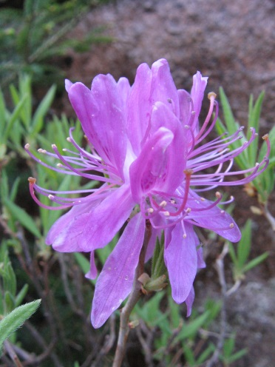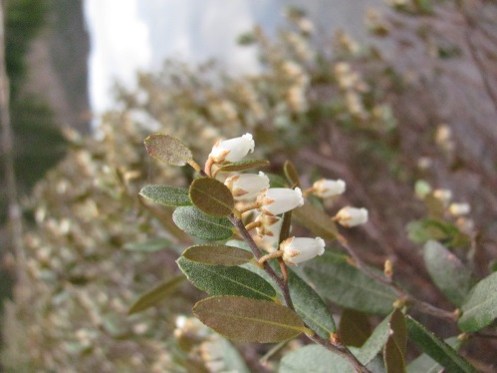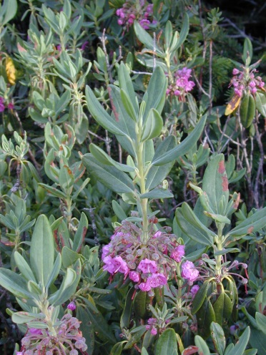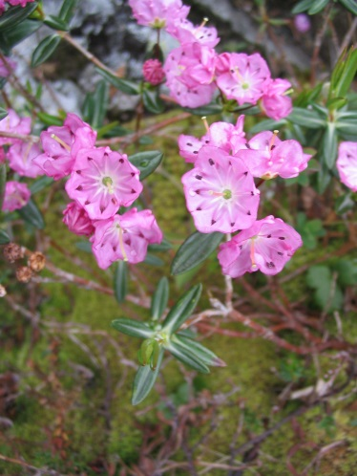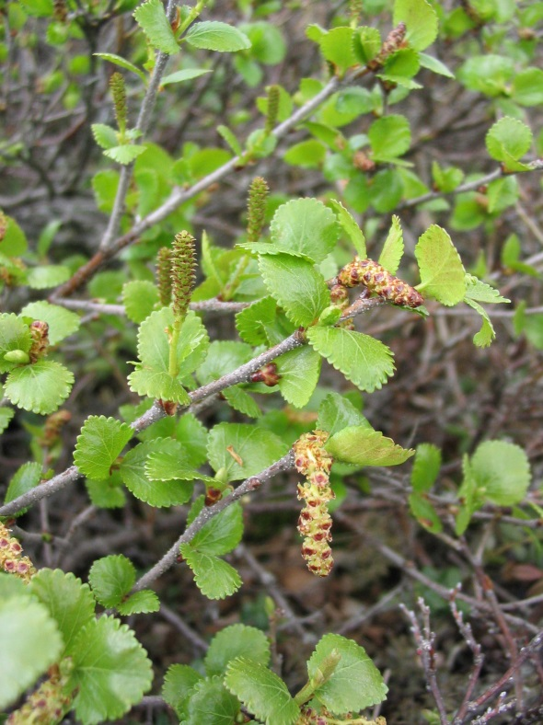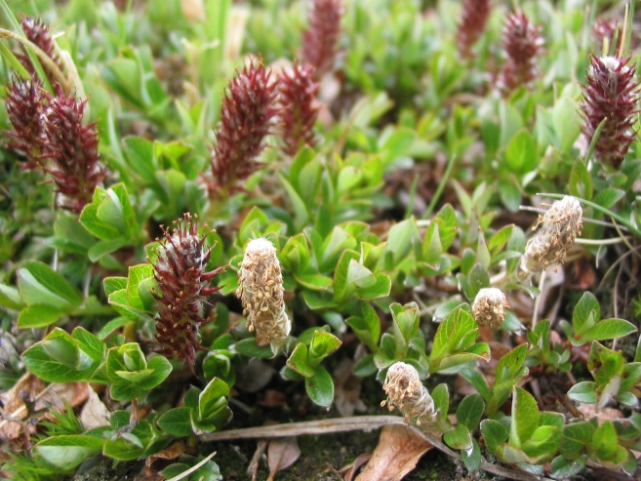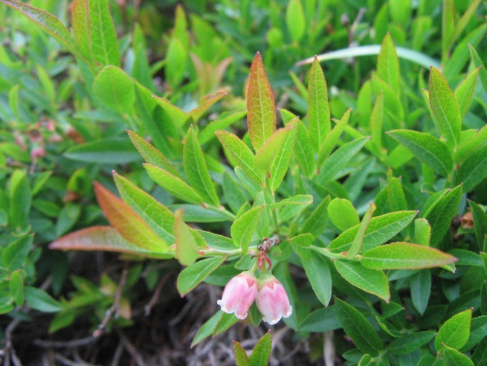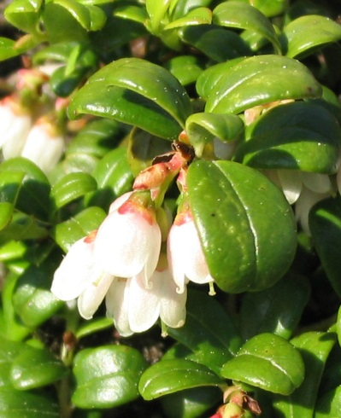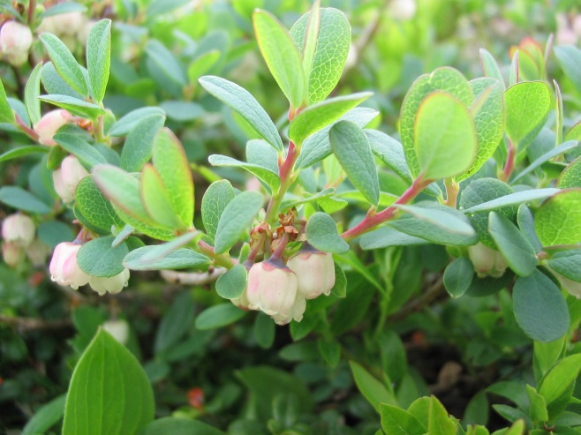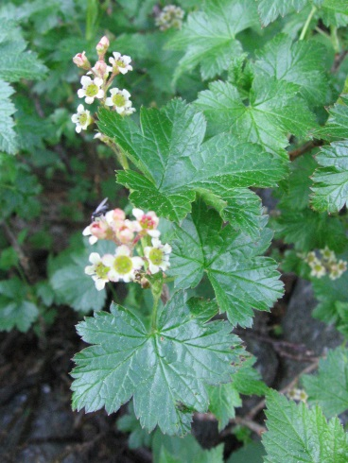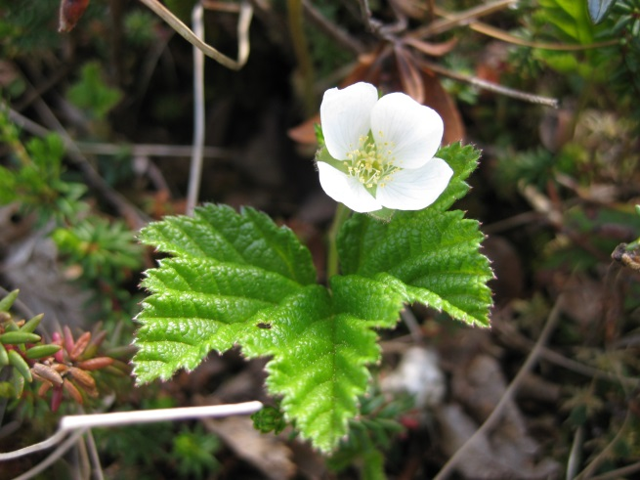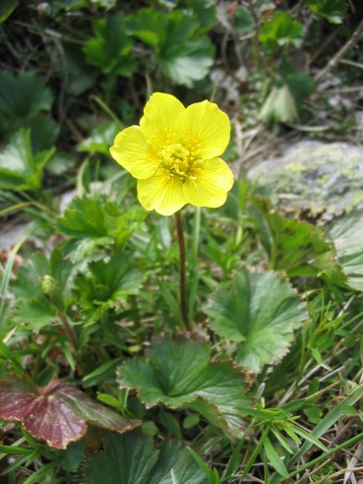

*Ribes glandulosum*

*Geum peckii*

*Geum peckii*

*Salix uva-ursi*

*Betula glandulosa*

*Vaccinium vitis-idaea*

*Vaccinium angustifolium / boreale*

*Rhododendron groenlandicum*

*Kalmia polifolia*

*Chamaedaphne calyculata*

*Rhododendron canadense*

*Kalmia angustifolia*

*Vaccinium uliginosum*

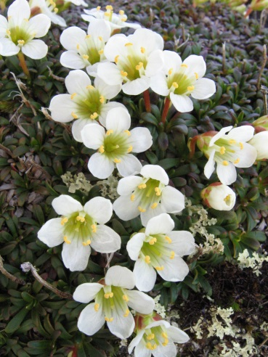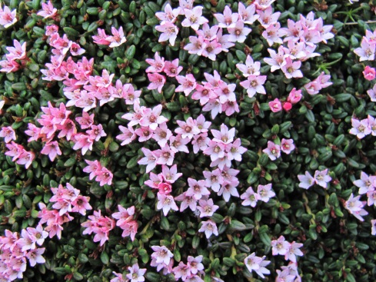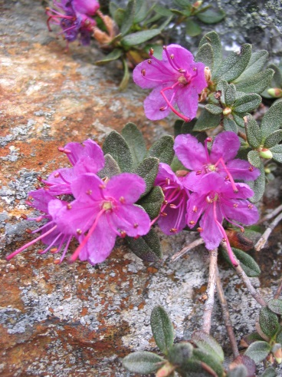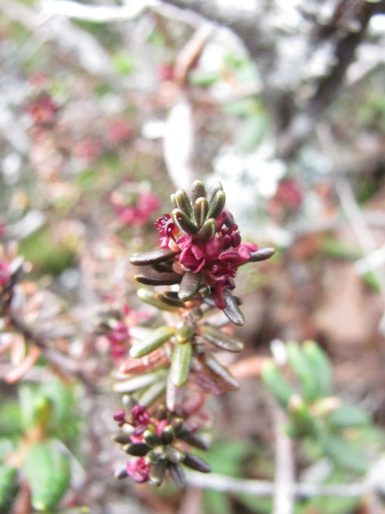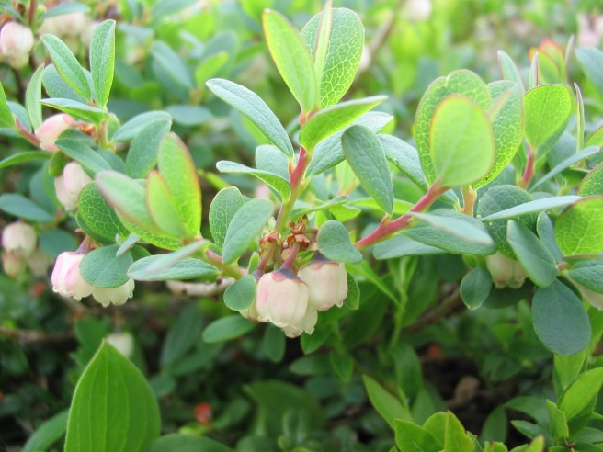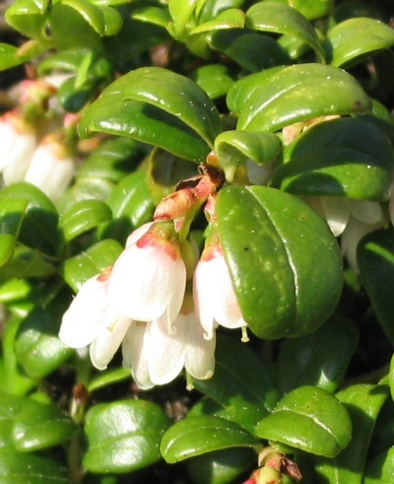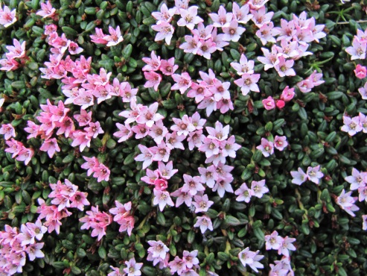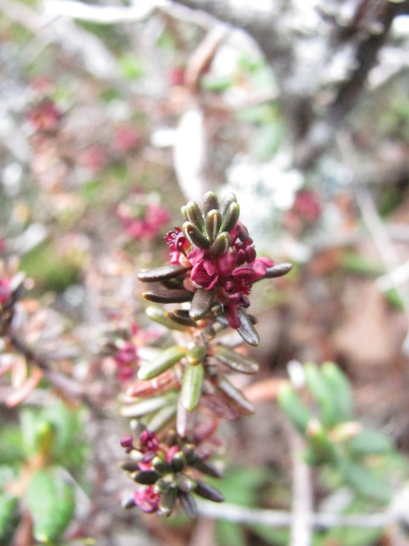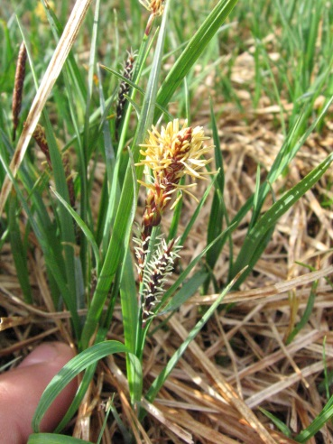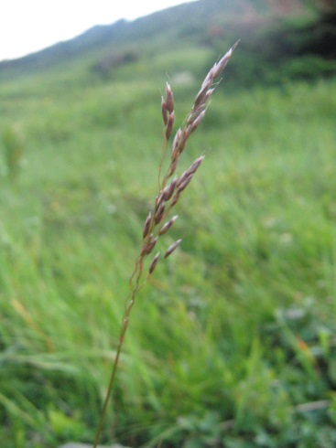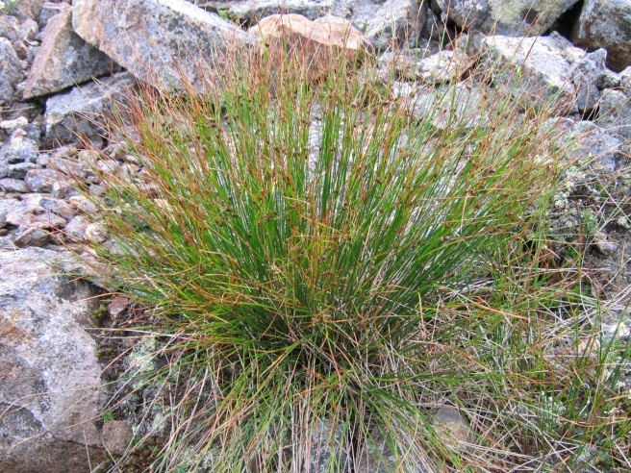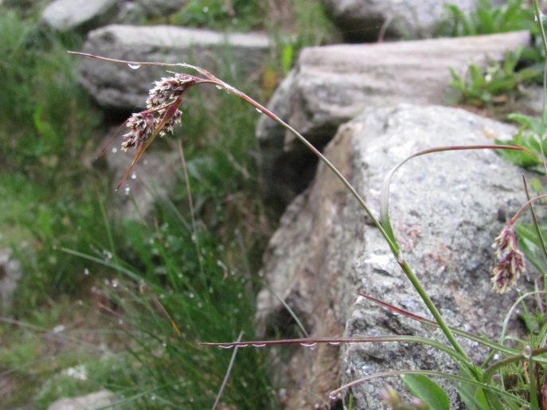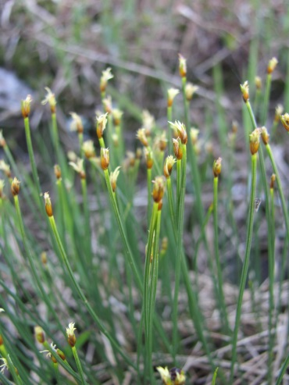

*Diapensia lapponica*

*Vaccinium uliginosum*

*Empetrum nigrum*

*Kalmia procumbens*

*Kalmia procumbens*

*Empetrum nigrum*

*Vaccinium vitis-idaea*

*Rhododendron lapponicum*

*Luzula spicata*

*Juncus trifidus*

*Carex bigelowii*

*Trichophorum caespitosum*

*Deschampsia flexuosa*

Supplementary Figure 1. Mountain Watch target species (framed in red) and their “look-alike” species in the Presidential Range alpine habitats, New Hampshire. Photo credits: AMC.